Hsin Miao (Daniel) Lee

Chloe McPherson

Floyd (Richie) Richardson

**ME 557 Final Project: Flying Spaceship Adventure**

Project Overview:

The goal of this project was to create a spaceship that flies around space that the user can control using the keyboard and mouse. The spaceship is flying nearby three spheres/planetary bodies. In order to generate a project that would meet our goals, we started with code that we had written for our previous homework assignments, such as lighting, environment mapping, and navigation. We added more functionality to these codes to meet our goals. The spaceship that we used was a model that we downloaded from turbosquid. The spaceship started as combination of triangular and quadrilateral meshes, but we used Meshlab to convert it solely to triangular meshes for us to import into Visual Studio.

For this project, Richie spent time creating the spaceship navigation and keyframe animations, and Hsin and Chloe have been working on creating and texturing the spheres and incorporating light into the scene.

Rubric Categories/Functions:

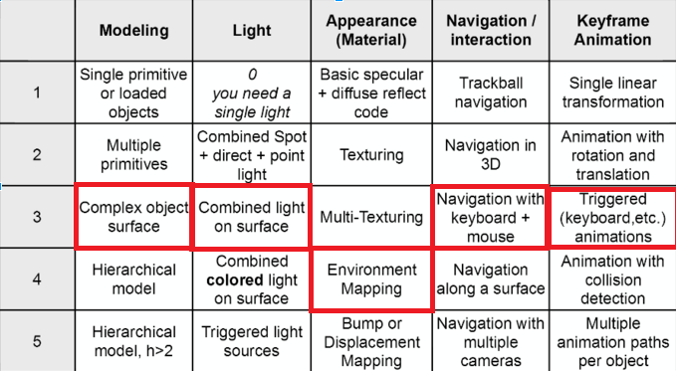

* Red bracket means our targets.

Results:

Presently, our code represents a spaceship which flies around the scene using the w, a, s, d, q, and e commands, which is carried out simultaneously with trackball navigation. Below are the functions for each of the keys used:

* W allows you to move forward
* S is used for moving backward
* A turns the spaceship left
* D turns the spaceship right
* Q turns the spaceship’s nose down
* E turns the spaceship’s nose up.

Unfortunately, the linear and angular momentums are not conserved in the present model. There also exist three heavenly bodies: a red planet, it's purple moon and a yellow sun. Each uses the same light source (located at the sun) and a planetary texture.

Challenges:

In coding the spaceship, we had to load an .obj file. This required installation of MeshLab. It also meant that any interpolation functionality or reporting of the spacecraft position had to be added to the GLObjectObj class. A new class was created for this purpose, GLObjectObjInt. Originally, the spaceship was intended to fly in a manner where the trackball directed the ship, and "w" and "d" accelerated and decelerated the ship, and the ‘Over-the-shoulder’ camera proved too difficult to implement in the time we were allotted.

We also had several Issues adding textures to the heavenly bodies. The code had the habit of always showing the same texture on all three spheres, even when each sphere had its own assigned texture that was mapped to different texture coordinates. Instead we worked to separate the textures for each sphere into separate .cpp files to call them from the main file, but we repeatedly ran into errors with this method as well.